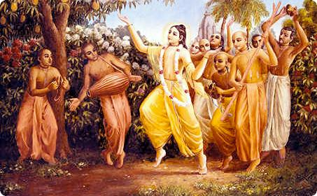
Soldiers of Godhead
August 2011 Edition
www.soldiersofgodhead.yolasite.com
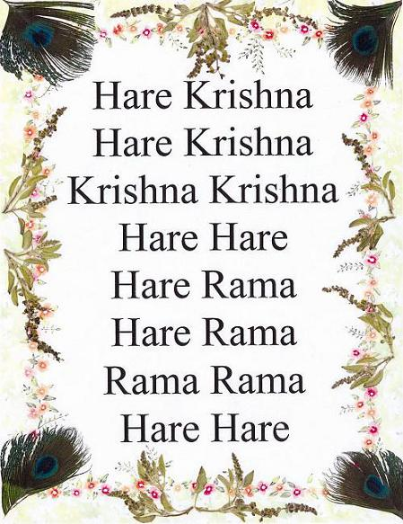
Chant Hare Krishna and be happy!
Message of the Acharya
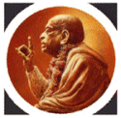
" Our Movement is a declaration of war against Maya. That you can understand very well, so we have to recruit many fighting soldiers-so do it vigorously! " -Srila Prabhupada
“…win the war with Maya and establish Krishna Consciousness as the perfect way of life for every living entity.”
(Srila Prabhupada Letter, 15/11/1971)

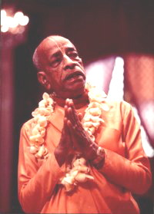
Dedicated to His Divine Grace
A.C Bhaktivedanta Swami Prabhupada-Founder Acharya of the International Society for Krishna Consciousness.

Contents
Sr.no Topic Page no.
- Myths about ISKCON. 7.

- Original 1972 Edition of Bhagavad-Gita As It Is, Available Soon From BBT. 15.

- Jagannath Puri Temple Resists Suggestions On Entry Of Non-Hindus. 18.

- A Celebration of Cows on Krishna’s Birthday 20.

- Letter by Srila Prabhupada. 25.

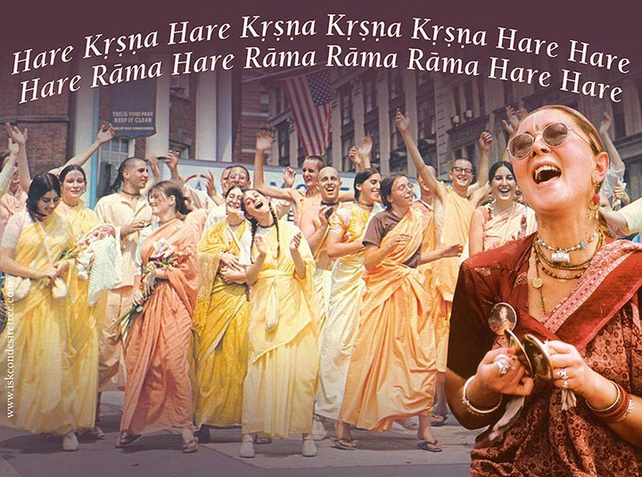

- Myths about ISKCON.
The International Society for Krishna Consciousness (ISKCON) belongs to the Gaudiya Vaishnava sampradaya (denomination or tradition), an ancient monotheistic tradition within Vedic or Hindu culture. ISKCON was established on July 11, 1966 by His Divine Grace A.C. Bhaktivedanta Swami Prabhupada (affectionately called Srila Prabhupada). It began in a small storefront in New York and has since developed into a worldwide confederation of over 11,000 temple devotees, 980,000 congregational devotees, and is comprised of more than 350 centers, 60 rural communities, and 55 restaurants worldwide.
The mission of this nonsectarian, monotheistic movement, popularly known as the Hare Krishna movement, is to promote the well being of society by teaching the science of Krishna consciousness according to the Bhagavad Gita and other ancient Vedic scriptures of India.
With the growing influence and awareness about ISKCON, have also come many misconceptions, some of them trivial, bordering humorous (like do I have to become bald to join ISKCON?) to much more serious (like does ISKCON deny the existence of other religions?). In this article, we will examine the more common Myths related to ISKCON and explain the facts.
Myth: ISKCON is an American organization.
Fact: ISKCON is non-sectarian in all respects, including nationality. It has temples all over the world managed and attended by local people of that region. Devotees often travel to different temples all over the world serving the deities, preaching and performing temple services as and when needed.
Myth: ISKCON propagates a predominantly Hindu religion.
Fact: Hindu culture is vast, and the term encompasses numerous theologies, philosophies religious traditions and spiritual cultures. ISKCON propagates the timeless Vedic philosophy which is not limited to any religion. The concept of God consciousness, devotional service and associating with God by remembering His name, His pastimes and following His instructions is universally preached in all spiritual walks of life and is explained in the Vedas as the 'sanatana dharma', the basic duty of all living entities.
Myth: ISKCON is a new-wave religion
Fact: ISKCON belongs to the Brahma Sampradaya, emanating from Lord Brahma and is one of the four authorized Vaishnava sampradayas (the other three are the Sri or Lakshmi, Rudra and Kumara sampradayas). The founder acarya Srila Prabhupada belongs to an unbroken disciplic succession started by Sri Krishna through Lord Brahma and includes authorities like Narada Muni, Srila Vyasadeva, Sripada Madhavacarya and Caitanya Mahaprabhu.
Myth: ISKCON uses American wealth to fund its project over the world.
Fact: All temples in ISKCON are mostly self sufficient and rely on their local congregation, book distribution and festivals to sustain and expand.
Myth: ISKCON is very aggressive in its preaching.
Fact: Devotees are naturally very compassionate and eager to share their love of Godhead with others. The Vedic scriptures enjoin that there is no activity as holy as spreading the name and teachings of God. However they also respect the views, background and practices of different people at all times. ISKCON does see it as its mission to accept with open arms any sincere soul who declares a need for spiritual shelter and guidance. There is a definite missionary spirit in Vaishnavism and Hinduism, but its practice is not governed by an exclusionist conversion model. From a Gaudiya Vaishnava perspective, ISKCON works not at 'conversion' but spiritual development.
Myth: ISKCON has been altered to suit the westerners
Fact: ISKCON is based on the potency of disciplic succession. The original word is passed from spiritual master to disciple without any modifications. The philosophy, practices, principles and any apparent deviation have been clearly enunciated and authorized by the Vedic scriptures. ISKCON requires that all initiated devotees strictly follow the four regulative principles (no meat eating, no intoxication, no gambling, no illicit sex), chant at least sixteen round of Japa daily and seriously study, understand and assimilate the Vedic scriptures like Bhagavad Gita, Srimad Bhagavatam etc.
Myth: ISKCON has turned religion into a public show.
Fact: People are often bemused and sometimes angered by the public sankirtans performed by ISKCON. However the scriptures recommend sankirtan as the yuga dharma for the current age of Kali. The traditional ratha yatra held annually in Puri is a classic example of this. The Nagara Sankirtana (town chanting) movement inaugurated by Caitanya Mahaprabhu has been followed in India for centuries and spontaneously engages even unwilling people into devotional service by shravana (hearing) and kirtana (singing) the Lord's name. However, these public displays are sustained by serious introspection, study of the scriptures and hours of daily Japa meditation and deity worship.
Myth: Deity worship standard in ISKCON does not come up to the level of traditional temples in India.
Fact: ISKCON temples are highly acclaimed in India and the rest of the world for exactingly high standard of deity worship. There are daily six aratis, regular bhoga offering beginning from early morning at 4:30AM, qualified priests and Brahmans expertly trained in deity dressing and worship.
Myth: ISKCON has very few people from Brahman families.
Fact: In Bhagavad Gita (18.42-44), Sri Krishna clearly states that the Varna (caste) of a person is decided by his activities, not by birth. At ISKCON all devotees follow rigorous regulative principles and are carefully guided and observed by their spiritual masters before they become eligible to receive their first (Harinam) or second (Brahamanical) initiation. All initiated devotees in ISKCON take a vow to adhere to the four regulative principles (no meat eating, no intoxication, no gambling and no illicit sex) and chant at least sixteen rounds of Japa every day.
Myth: ISKCON propounds a culture of conversion
Fact: ISKCON has the basic belief that God consciousness is universal and all major religions are bona fide. With this understanding, ISKCON does not have a mission to proselytize members of other faiths. There are fully practicing Christians and Moslems who are active members of ISKCON. Similarly there are many that have whole heartedly embraced the Vedic teachings explained in the ISKCON temples. Conversion is an individual experience, a very personal spiritual journey that transcends religious institutions and sectarian affiliations. Conversion models that depend on exclusionist demands of affiliation may often do so without considering the Lord's supremacy, independent in truth.
Myth: ISKCON like other temples and churches is always asking for money.
Fact: It is customary for religious organizations, engaged in spiritual service, to depend on the congregation for support. While our temples do need money to support, they are ultimately only dependant on the mercy of Sri Krishna for this. People contribute voluntarily, only when they are eager to utilize their wealth in the service of Sri Krishna, and ISKCON takes utmost care that this is done optimally. However no one is excluded on the basis of their wealth or contributions. The greatest spiritual realizations that one can have is that he is not the proprietor of anything - everything belongs to Krishna and is best used in his service.
Myth: ISKCON has diluted religion by making it high-tech.
Fact: Temples in ISKCON are known to rely on latest technology to attract visitors. Sannyasis fly around the world and keep in touch using Email from their laptops. But all this is being used in the service of Sri Krishna. In itself technology is neither good or bad, it is the intent of its use that makes the difference. The concept of 'yukta vairagya' using everything in the service of Krishna is fully understood and carefully followed in ISKCON.
Myth: ISKCON does not have any social obligations.
Fact: ISKCON is the largest Vegetarian Food Relief organization in the world. It distributes a plate of prasadam every five seconds, some times in the midst of war and famine situations. At different places, depending on the resources and interest, ISKCON has established hospitals, schools, farm communities and restaurants. However, they do not distribute just food, they distribute prasadam (food that has been sanctified by offering to Krishna), which not only alleviates physical hunger but also provides spiritual nourishment. The focus is always on the spiritual growth of a person, not just the temporary material body.
Myth: ISKCON requires its members to shave up and become bald!
Fact: The only basis of joining ISKCON is simple: a sincere desire to develop God consciousness. There are attendant processes while making spiritual advancements, like austerity, simplicity and frugalness. Becoming bald is simply one of the prescribed ways to lead a simple, austere life.
We hope that this has cleared many common misconceptions about ISKCON held by people in different countries and denominations. As always, we welcome from our readers, discussions on any of these points.
Hare Krishna!

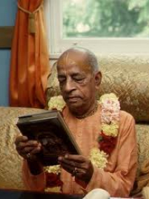

- Original 1972 Edition of Bhagavad-Gita As It Is, Available Soon From BBT.
Source: www.news.iskcon.com
Back by popular demand, Jayadvaita Swami and the Bhaktivedanta Book Trust International trustees have recently decided to reprint Srila Prabhupada’s original 1972 Macmillan edition of Bhagavad-Gita As It Is.
The ’72 edition is being printed in English and will be available for mass distribution. Inside sources say that the printing is being done in India and all regional divisions of the Bhaktivadanta Book Trust will be stocking the books.
The important meeting when the landmark decision was made took place at the beginning of 2011. The new, or should we say “old books”, should be available to devotees in all parts of the world sometime in mid-to-late 2011. So far, there has been no word on prices. For more information, please contact the Bhaktivedanta Book Trust regional division office on your continent. For continuing news coverage and updates please visit oneiskcon.com
Hare Krishna!

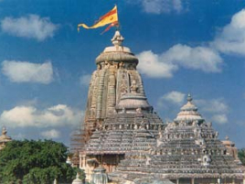
Sri Jagannath Mandir, Jagannath Puri, Orissa, India.

- Jagannath Puri Temple Resists Suggestions On Entry Of Non-Hindus.
Rajaram Satapathy for The Times of India on 25 Aug 2011
PURI: Lord Jagannath of Puri has perhaps courted more controversies than any other deity in India. The gigantic 12th century edifice has been the scene of several conflicts and debates, the latest being the right of non-Hindus to enter the temple. The fires were stoked again recently when Rajya Sabha member Pyari Mohan Mohapatra, the man who matters most in the ruling BJD, suggested that non-Hindus be allowed into the temple to boost its tourist potential.
The reaction to the statement made at a meeting convened by the state's hotel and restaurant association was swift and loud — protests, dharnas, demonstrations and effigy burning episodes greeted Mohapatra wherever he went. The leader has since refused to back off. Mohapatra, interestingly, is not the only one in favour of changing the temple's ancient traditions.
Former chief minister and now Assam governor JB Patnaik has nearly the same take, except that he is demanding that ISKCON devotees be allowed in. They, he says, have played a pivotal role in taking the Jagannath cult and the chariot festival to the world. A peep into the temple's eventful history can perhaps explain some of this prickliness.
Hare Krishna!
Soldiers of Godhead view:
It has been the age old tradition of the Jagannath Temple to restrict entry of non-Hindus into the temple. For the sake of promoting tourism, generating revenue, and in the name of removing caste, cultural or religious differences, this tradition cannot be compromised. Non-Hindus (they may belong to any country or organization) must not be allowed into any prominent Hindu temples in order to maintain the temple sanctity.

- A Celebration of Cows on Krishna’s Birthday.
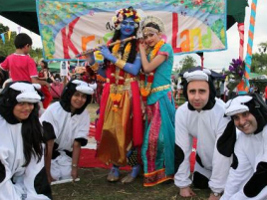
By Radha Mohan Das for ISKCON News on 25 Aug 2011
The world’s largest Janmashtami festival outside of India at Bhaktivedanta Manor attracted more than 60,000 pilgrims on 21st and 22nd August. This year celebrated the launch of the Ahimsa Dairy Foundation, which sells milk from cows that will be retired when their milking days are over and uses bulls to work the land.
Ahimsa means non-violence and the not-for-profit company has just begun distributing slaughter-free, organic milk in the London area in time to celebrate the birthday of Krishna, who was the guardian of cows.
The Foundation has a herd in Kent, but takes its inspiration for cow protection from the Manor’s farm, which supplies the temple with milk and dairy products from its Meuse Rhine Issel and Dairy Short-horn cows. No cow, calf or bull is ever killed and all are allowed to live out their natural lives.
Ahimsa Slaughter-free Milk costs £2:25 a litre and there is a 15p additional charge for doorstep delivery.
As pilgrims entered the huge festival site, they passed through the new farm complex which has been recognized as a blue-print for compassionate and sustainable farming which will change the way people think about how their food is produced.
Radhanath Swami was the principle guest at the event. “I have noticed people are beginning to care more about what they consume and how it got to their plate,” said the farm manager Syamasundar das , “The belief in the old adage ‘you are what you eat’ shows the change in people’s awareness that they are beginning to care more how food and drink is produced,” When talking about the Janmashtami festival, The President of Bhaktivedanta Manor Srutidharma Das said: “It is a festival of peace in what are troubled times. Krishna protected cows as sacred animals and we are delighted to be celebrating the cow at this year’s festival. Ahimsa is a very important belief in our tradition and the cow symbolises peace and prosperity in society. When the relationship between humans and cattle is correct everything in the world is in harmony.”
The festival featured hundreds of children with their faces painted blue, many carrying flutes and wearing peacock feathers in their hair, dressing like Lord Krishna as part of the festive spirit.
Another highlight included a flowered walkway through the spiritual gardens and woodland. Visitors will journey through the life and pastimes of Lord Krishna climaxing with a glimpse of the spectacular deity of Krishna decorated with thousands of flowers.
The entire festival is managed and run by 1500 volunteers from the community who gather every evening after work for a month prior to the event and put in countless hours of hard work for the occasion.
Hare Krishna!

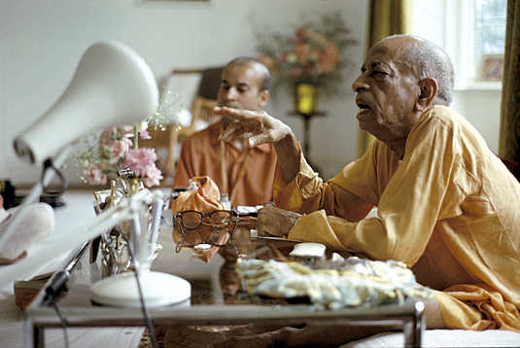

- Letter by Srila Prabhupada.
18 December, 1975
Bombay
My Dear Acyutananda and Yasodanandana Maharaja,
Please accept my blessings. I beg to acknowledge receipt of your letter dated December 11, 1975. The books are already on the way. Sankirtana will always be appreciated, because it is the special blessings of Lord Caitanya Mahaprabhu on the people of this fallen age of Kali. Sukadeva Goswami says, this age is an ocean of faults, but there is one boon, in this age one gets the same result as was achieved in former ages through elaborate temple worship, costly sacrifices, or introspective meditation, simply by chanting the Holy Name of The Lord.
It is for this reason only that this Hare Krishna movement has spread so quickly all over the world. The people of this age are so fallen they are like cats and dogs. What cats and dogs will understand about philosophy? If a dog is barking and you speak with him very nicely, "my dear dog, please try to control your barking, it is very disturbing." Will he be able to understand? Therefore we simply throw him a bone, and he is satisfied.
So distribute prasadam, and chant Hare Krishna. For the mass of people this is the only medicine. Lord Caitanya never spoke philosophy in public, he held kirtana and distributed prasadam. When he meet Sarvabhauma Bhattacarya he talked high philosophy, otherwise, Chanting and prasadam distribution.
I hope you are well.
Your ever well wisher,
A. C. Bhaktivedanta Swami
ACBS/sd
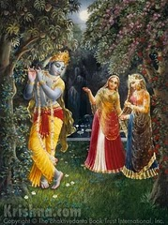

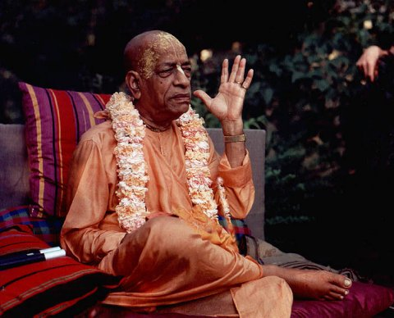

Written, Edited, Published and Distributed by,
Vinay Chakraborty.

Our special thanks to www.news.iskcon.com

For more information visit-
www.soldiersofgodhead.yolasite.com

Do send in your views, comments and suggestions to vinay.chakraborty@yahoo.com

Hare Krishna!

